Year 10 Science (General)
Semester 1 Examination Revision 2019
Physical Sciences

1. What is the difference between distance and displacement?

2. Convert the following speeds to metres/second (m/s).

(a) 67 cm/s

(b) 275 km/h

(c) 35.8 mm/s

3. A man drives his car 800 m due East and then turns North, driving 300 m before stopping at a petrol station. It took him 120 s to get there.

(a) What distance he has driven.

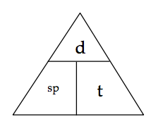

(b) Calculate his average speed for the journey.


4. A balloon filled with hydrogen gas has a velocity of 40 m/s East. How long will it take to go 450 m ?


5. What is the average speed of a plane if it flies 2700 km in 2.3 hours? Give the answer in km/h.

6. The driver of a car moving at 100 km/h along the freeway sees an emergency 80 m ahead and moves her foot from the accelerator to the brake. This takes 1.45 s to occur. How far has the car travelled before the driver has activated the brakes.


7. The following ticker tape show the constant motion of an object in the laboratory. Determine the value of the average speed shown. Show all of your working.



8. Use the scale in the map below to work out the distance and displacement from the Fairmont Empress hotel to Craigdarroch Castle. Use either the blue or grey route.

Remember to give a bearing or direction for the displacement.

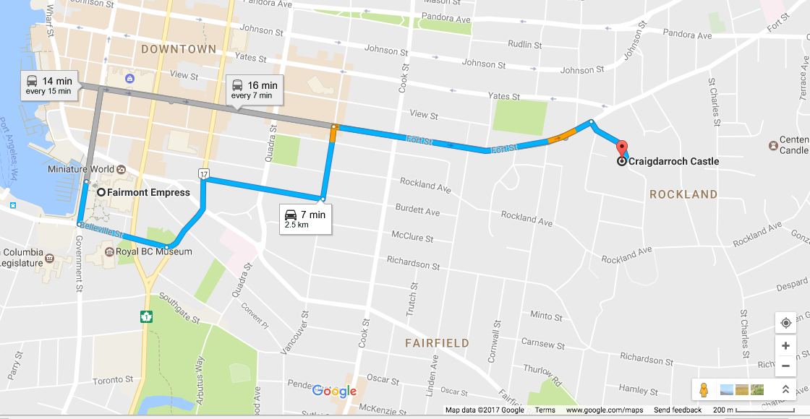

distance:

displacement:

